**Exp 2 Design an LED Chaser light**

Circuit Diagram

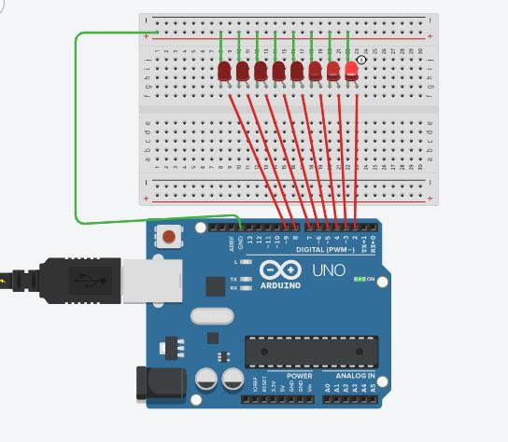

Theory

Concepts Used

1. Parallel circuit.
2. Arduino Uno’s digital input/output pins.
3. Code for the effects.
4. Bread-board.

Learnings and Observations

1. Improved problem solving and using Arduino UNO IDE.

Precautions

1. LEDs should be connected in right direction.
2. Check for any damages in the arduino cable.

Learning Outcomes

1. Working of a bread-board.
2. Improved understanding of the code used in Arduino IDE.
3. Connections on breadboard and working of Arduino IDE and Breadboard.